Day 60: Priority Encoder (4:2 and 8:3) Using Verilog HDL

4:2 Priority Encoder
Introduction: A priority encoder is a combinational logic circuit that generates a binary code for the highest-priority active input.
Design: The 4:2 priority encoder has four input lines and two output lines. If multiple inputs are active, the input with the highest priority is selected.
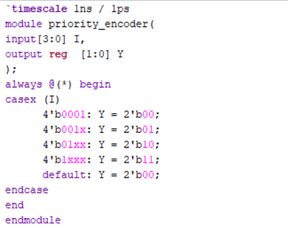
Testbench: Different input combinations are applied to the priority encoder. The output is checked to verify that the highest-priority active input is encoded correctly.
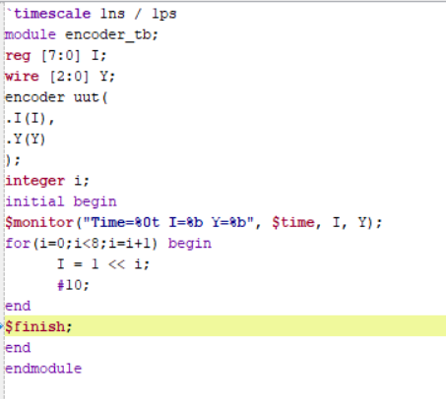
Waveform:The simulation waveform shows the input signals and the corresponding binary output. When multiple inputs are active, the output represents the highest-priority input.
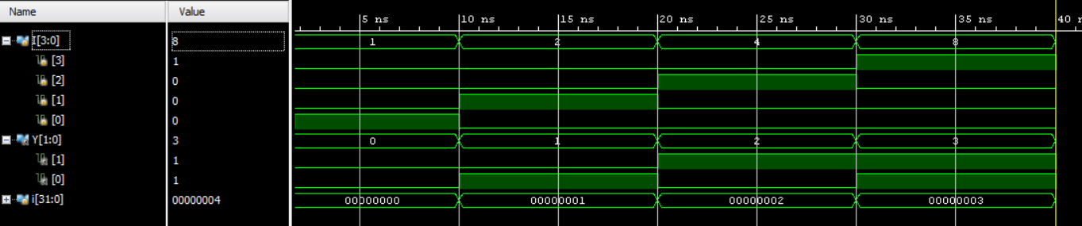
Schematic: The RTL schematic is generated in Xilinx Vivado to observe the internal logic structure and connections.
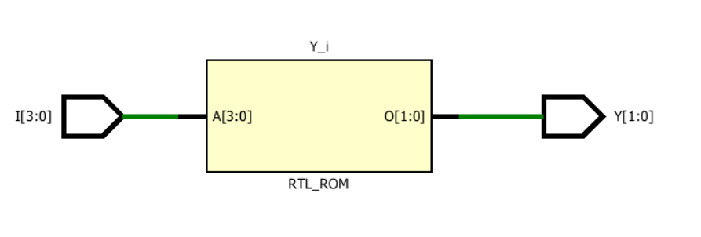

8:3 Priority Encoder
Introduction: An 8:3 priority encoder is a combinational logic circuit that converts the highest-priority active input into a 3-bit binary code.
Design: The 8:3 priority encoder has eight input lines and three output lines. When multiple inputs are active, the highest-priority input determines the output.
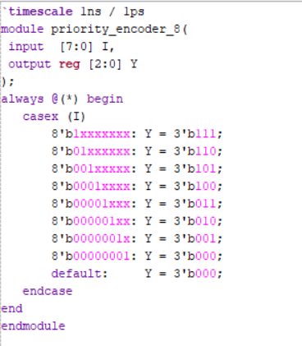
Testbench: Different input combinations are applied to the encoder using a testbench. The output is observed and checked to verify the priority operation
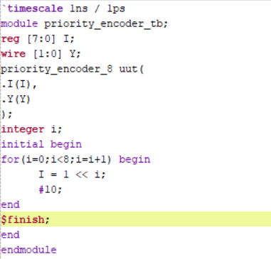.
Waveform: The simulation waveform shows the input combinations and the corresponding 3-bit binary output. The output changes according to the highest-priority active input.
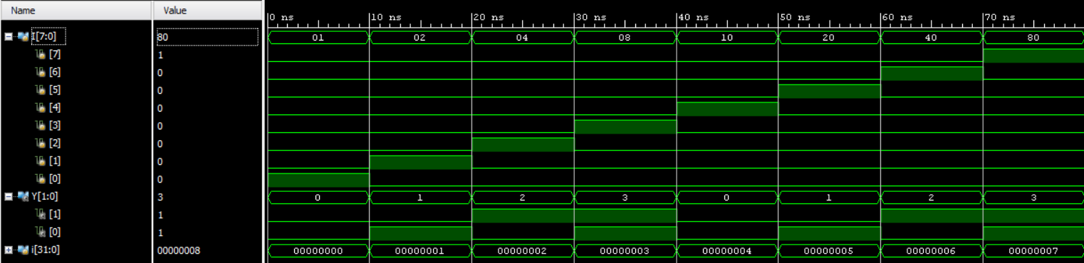
Schematic: The RTL schematic is generated in Xilinx Vivado to observe the internal logic structure and signal connections.
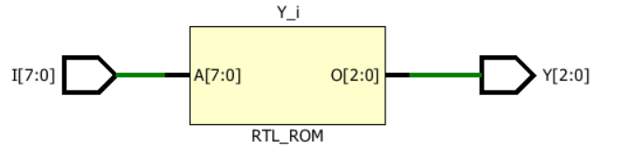

Observation: Both priority encoders generate the binary code of the highest-priority active input. Their functionality is verified through simulation using Verilog HDL and Xilinx Vivado.

#PHANEENDRA.SINGUSAU

